**Project**  
Bank loan data

select * from Bank_loan_data

KPI’s

* **Total loan application**

select COUNT(id) as total_loan_application from Bank_loan_data

* **Month to date total loan application**

select COUNT(id) as MTD_Total_loan_application from Bank_loan_data

Where year(issue_date)= 2021 And month(issue_date) = 12

* **Total funded amount**

select sum(loan_amount) as total_funded_amount from Bank_loan_data

* **MTD total funded amount**

select sum(loan_amount) as MTD_total_funded_amount from Bank_loan_data

where MONTH(issue_date) = 12 and year(issue_date) = 2021



* **Total amount received**

select sum(total_payment) as Total_amount_received from Bank_loan_data



* **MTD total amount received**

select sum(total_payment)as MTD_total_amount_received from Bank_loan_data

where MONTH(issue_date)= 12 and YEAR(issue_date)=2021



* **Mtd avg interest rate**

select ROUND(avg(int_rate),4)*100 as MTD_avg_interest_rate from Bank_loan_data

where MONTH(issue_date)= 12 and YEAR(issue_date)= 2021



* **MTD average DTI(debt to income ratio)**

select ROUND(avg(dti),4)*100 as MTD_avg_dti from Bank_loan_data

where MONTH(issue_date)= 12 and YEAR(issue_date)= 2021



* **Good loan percentage**

select

(count(case when loan_status = 'Fully paid' or loan_status = 'current' thenid end)*100)

/

count(id) as good_loan_percentage

from Bank_loan_data

* **No. of good_loan**

select COUNT(id) as good_loan_application from Bank_loan_data

where loan_status = 'Fully paid' or loan_status = 'Current'



* **Good loan funded amount**

select sum(loan_amount) as good_loan_funded_amount from Bank_loan_data

where loan_status= 'Fully paid' or loan_status = 'Current'

* **Good loan received amount**

select SUM(total_payment) as good_loan_recived_amount from Bank_loan_data

where loan_status = 'Fully paid' or loan_status = 'Current'



* **Bad loan percentage**

select

(count(case when loan_status = 'Charged off' then id end)*100)

/

count(id) as bad_loan_percentage

from Bank_loan_data



* **Bad loan application**

select COUNT(id) as bad_loan_application from Bank_loan_data

where loan_status = 'Charged off'



* **Bad loan funded amount**

select sum(loan_amount) as bad_loan_funded_amount from Bank_loan_data

where loan_status = 'Charged off'



* **Bad loan amount received**

select sum(total_payment) as bad_loan_Amount_received from Bank_loan_data

where loan_status = 'Charged off'

* **Group by all**

select

loan_status,

COUNT(id) as Total_loan_applications,

SUM(total_payment) as Total_amount_received,

SUM(Loan_amount) as Total_funded_amount,

AVG(int_rate * 100) as Interest_rate,

AVG(dti * 100) as DTI

From

Bank_loan_data

Group by

loan_status

* **MTD group by**

select

loan_status,

SUM(total_payment) as MTD_total_amount_received,

SUM(loan_amount) as MTD_total_Funded_amount

From bank_loan_data

where MONTH(issue_date) = 12

group by loan_status

* **Datename month wise data**

select

MONTH(issue_date) as Month_no,

datename(month,Issue_date) as Month_name,

count(id) as Total_loan_application,

Sum(loan_amount) as total_funded_amount,

sum(total_payment) as Total_received_amount

from bank_loan_data

group by MONTH(issue_date), DATENAME(month,issue_date)

order by MONTH(issue_date)

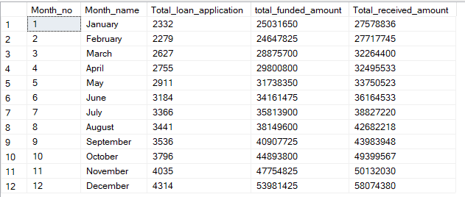

* **Address_State wise group by**

select

address_state,

COUNT(id) as total_loan_applications,

SUM(loan_amount) as total_funded_amount,

SUM(total_payment) as total_received_amount

from bank_loan_data

group by address_state

order by count(id) desc

* **Term wise group by**

select

term,

COUNT(id) as total_loan_applications,

SUM(loan_amount) as total_funded_amount,

SUM(total_payment) as total_received_amount

from bank_loan_data

group by term

order by term

* **Group by as emp_length**  
  select

emp_length,

COUNT(id) as total_loan_applications,

SUM(loan_amount) as total_funded_amount,

SUM(total_payment) as total_received_amount

from bank_loan_data

group by emp_length

order by emp_length

* **Group by wise Purpose**

select

purpose,

COUNT(id) as total_loan_applications,

SUM(loan_amount) as total_funded_amount,

SUM(total_payment) as total_received_amount

from bank_loan_data

group by purpose

order by count(id) desc

* **Group by home_ownership wise**

select

home_ownership,

COUNT(id) as total_loan_applications,

SUM(loan_amount) as total_funded_amount,

SUM(total_payment) as total_received_amount

from bank_loan_data

group by home_ownership

order by count(id) desc

